Disaster in Japan: How You Can Help
By Alla Byrne
Friday March 11, 2011 08:10 PM EST
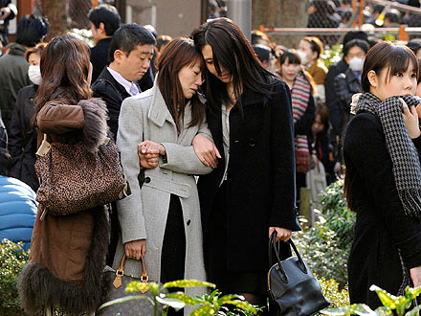
Evacuees stand around Shinjuku Central Park in Tokyo
Kyodo/Reuters/Landov
A massive earthquake and tsunami hit Japan Friday morning, killing thousands of people and devastating a nation, but relief organizations are stepping up to provide immediate assistance to victims.
Here are some ways you can get involved and help people:

• Convoy of Hope's Disaster Response team is in contact with partners in Japan and identifying areas in the greatest need of assistance. You can donate online at convoyofhope.org or text TSUNAMI to 50555 to donate $10 toward the relief efforts.

• AmeriCares is asking for donations so they can provide medicine and medical supplies to victims of the disaster.

• Global Giving has set up a relief fund where you can make a donation, which will be distributed to relief and emergency services in the affected region.

• Direct Relief International is reaching out to medical teams and emergency responders to offer assistance.

• Save the Children is mobilizing a response to the disaster in Japan with a focus on helping the youngest victims.

• International Medical Corps is sending medical supplies and relief teams to Japan. Help by donating $10 by texting MED to 80888.

• Make a $10 donation to the Red Cross by text messaging REDCROSS to 90999 or visit redcross.org to donate online.

If you're looking for a loved one in the disaster area, Google People Finder is a good place to start.

http://www.people.com/people/article/0,,20473235,00.html

